Heptagonal Antiprism
# Source: AI Source: Provided by: [Data Path: Persons Table -> ID Column: 1, Name_En Column: Motasem Essam] -> From: [ChatGPT] on [7/25/2026]
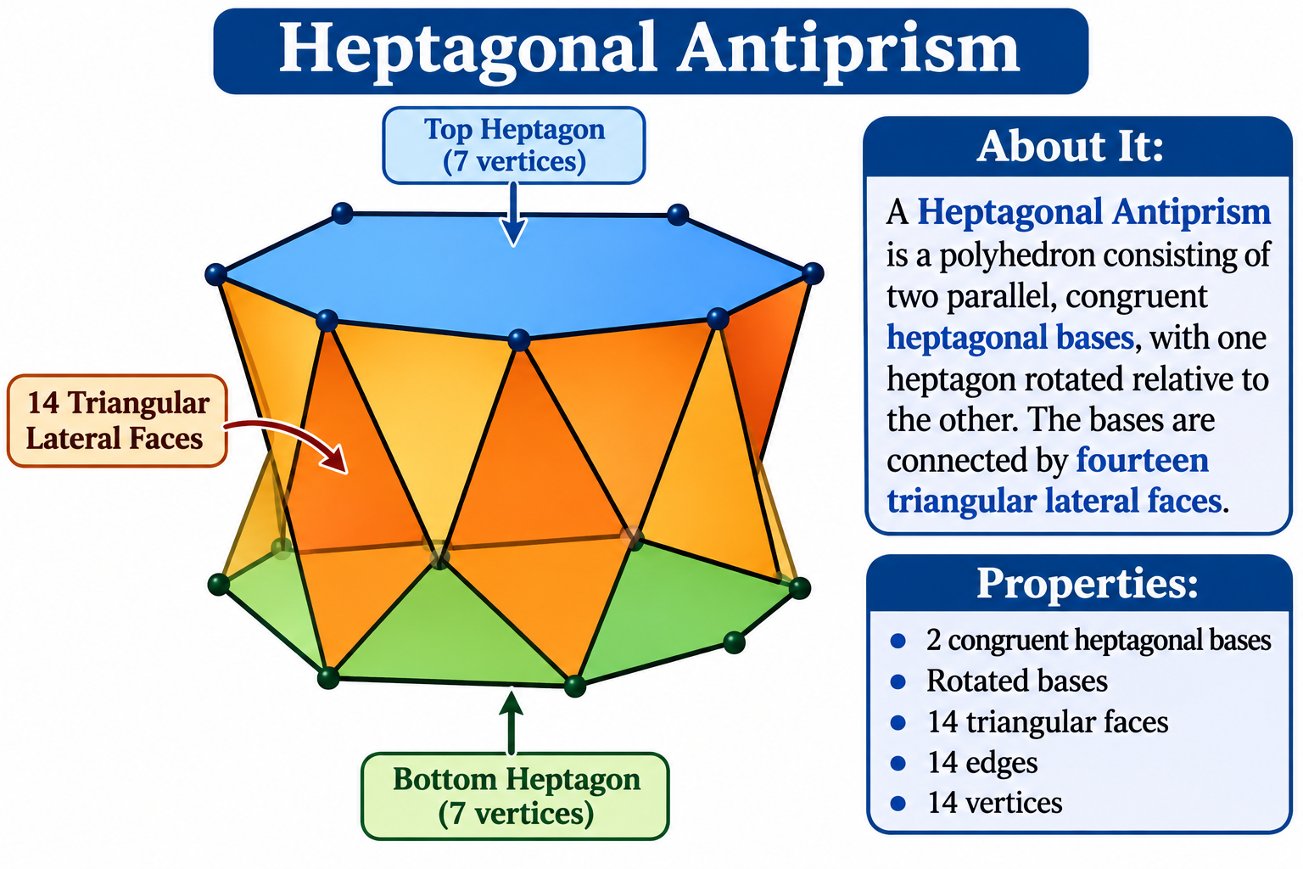

Definition
# Source: AI Source: Provided by: [Data Path: Persons Table -> ID Column: 1, Name_En Column: Motasem Essam] -> From: [ChatGPT] on [7/25/2026]
A Heptagonal Antiprism is a polyhedron consisting of two parallel, congruent heptagonal bases, with one heptagon rotated relative to the other. The bases are connected by fourteen triangular lateral faces.
It is a type of antiprism with heptagonal bases and a twisted arrangement of its lateral triangles.
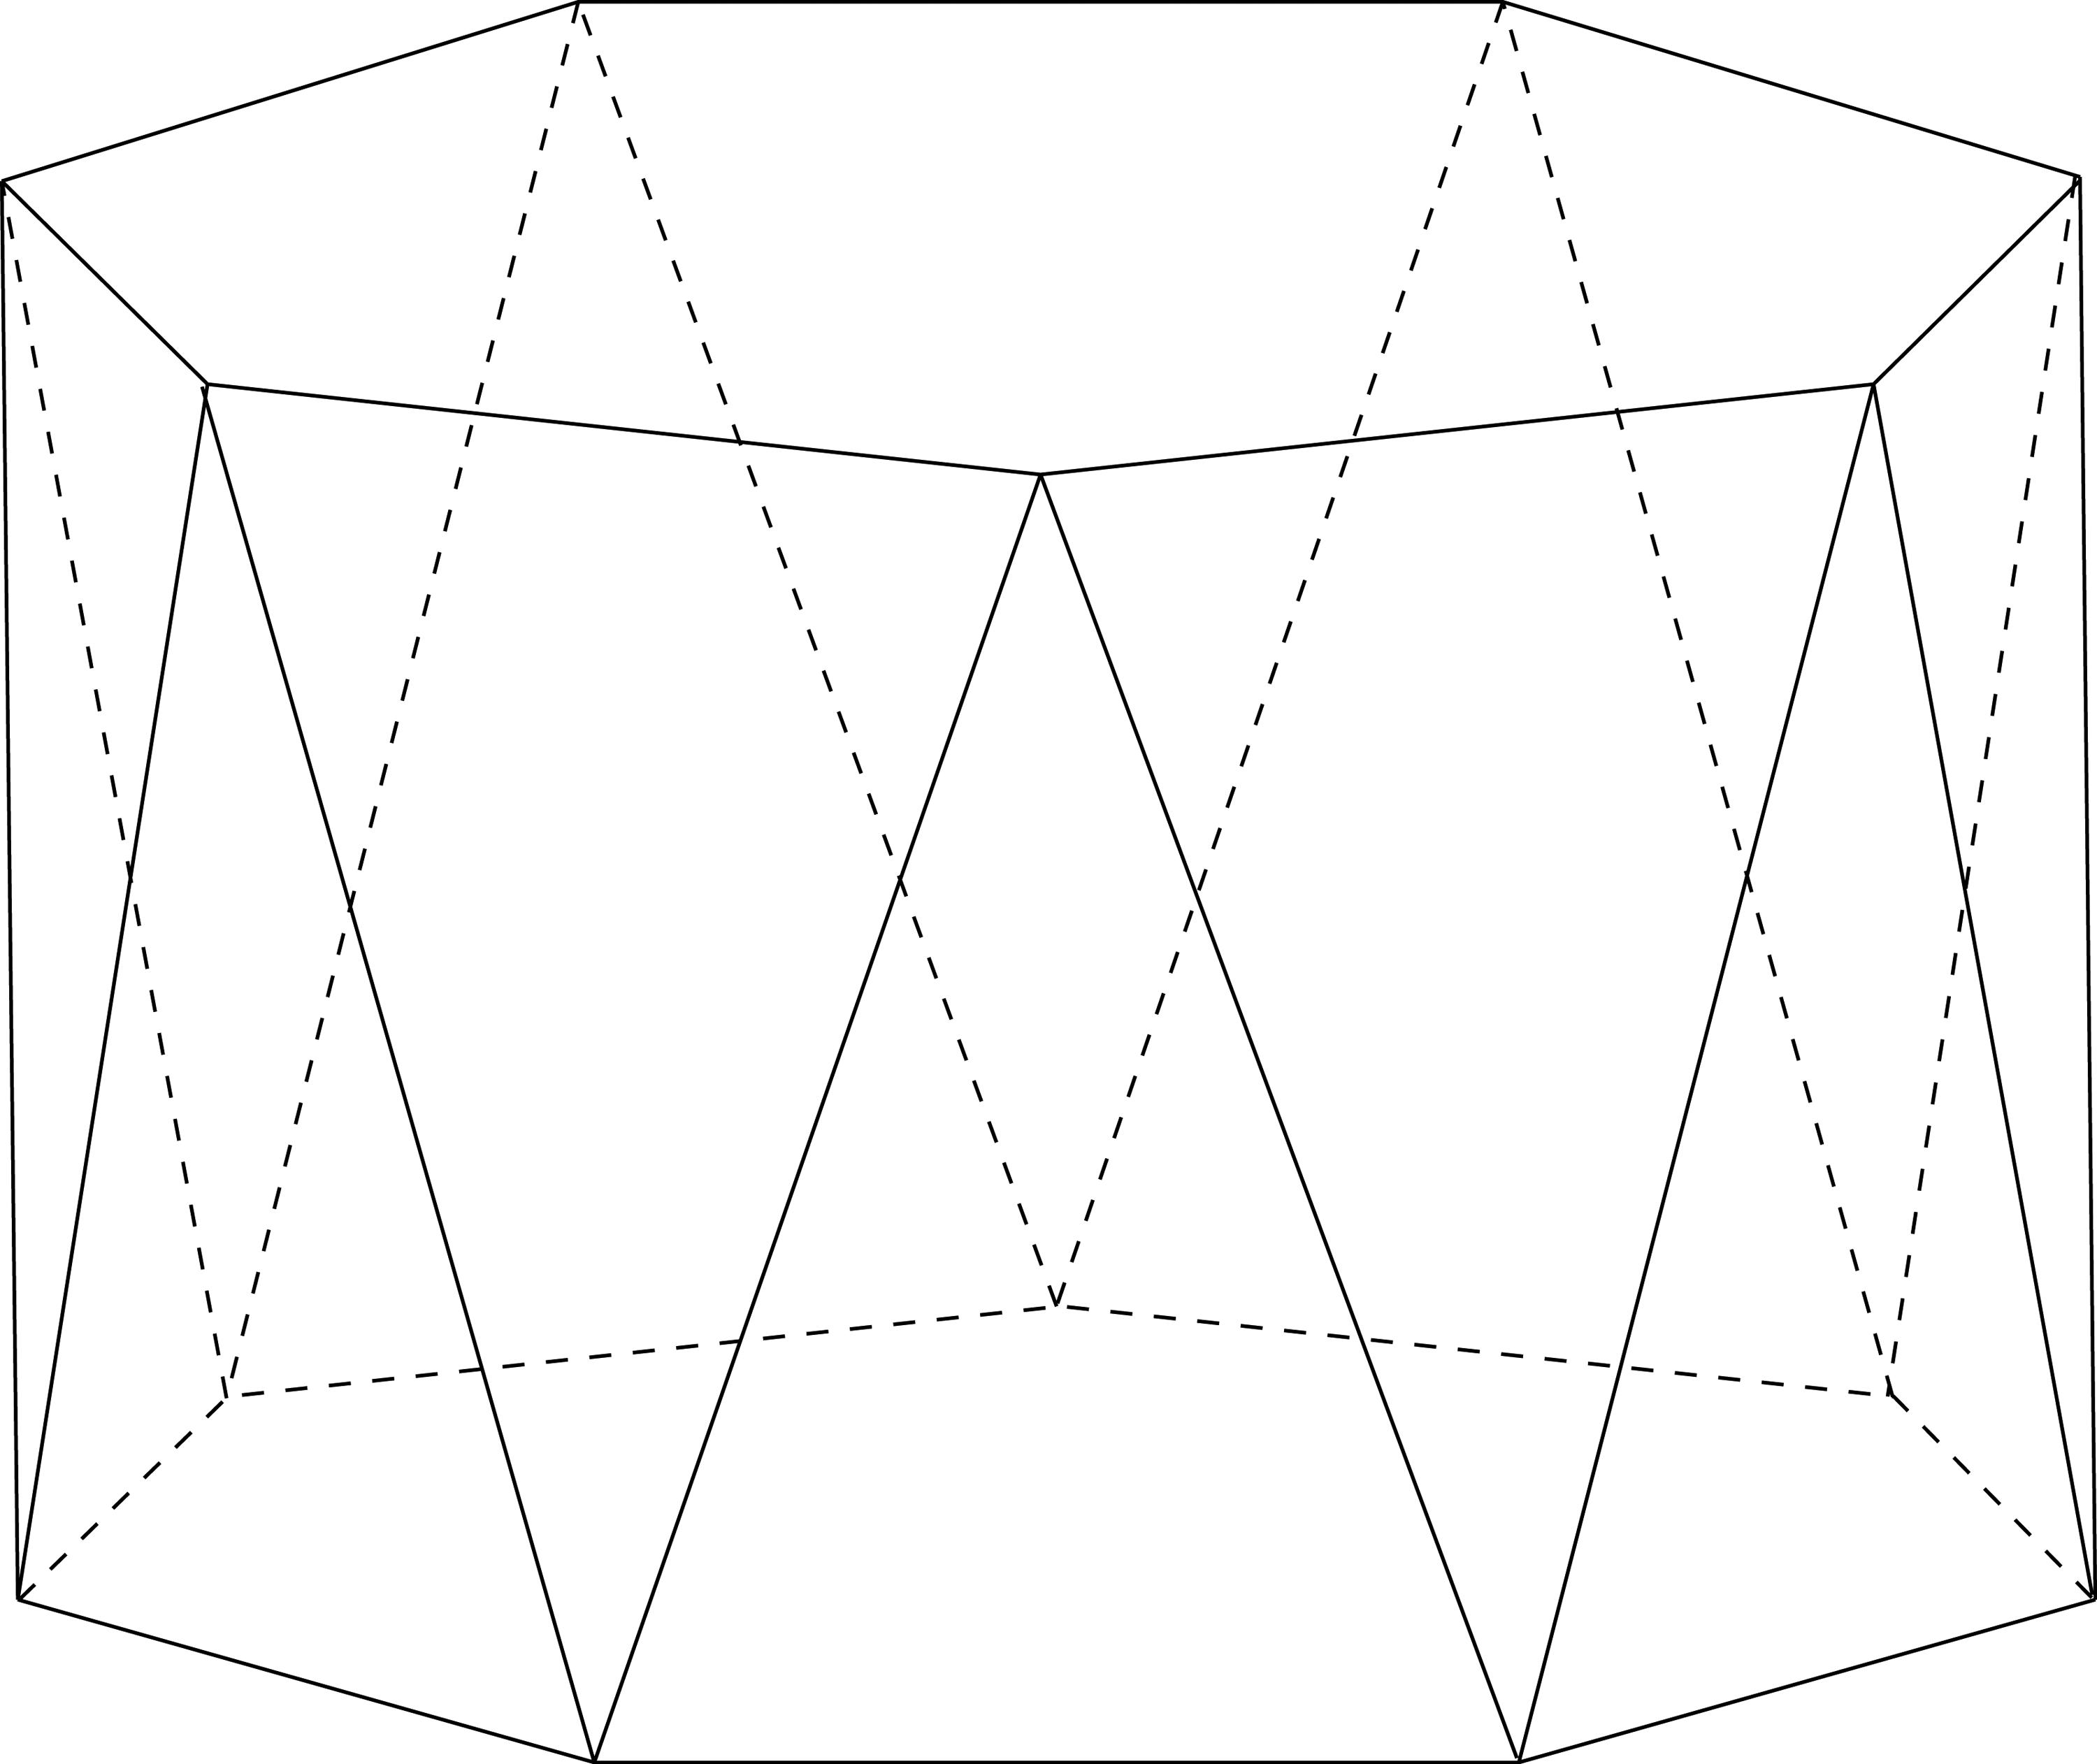

Geometric Structure
# Source: AI Source: Provided by: [Data Path: Persons Table -> ID Column: 1, Name_En Column: Motasem Essam] -> From: [ChatGPT] on [7/25/2026]
The heptagonal antiprism consists of:
- Upper Heptagonal Base: A heptagon forming the top face.
- Lower Heptagonal Base: A congruent heptagon forming the bottom face, rotated relative to the upper base.
- Triangular Lateral Faces: Fourteen triangles connecting the two heptagonal bases.
- Vertices: Fourteen vertices, with seven on each base.
- Edges: Twenty-eight edges connecting the vertices.

Face Composition
# Source: AI Source: Provided by: [Data Path: Persons Table -> ID Column: 1, Name_En Column: Motasem Essam] -> From: [ChatGPT] on [7/25/2026]
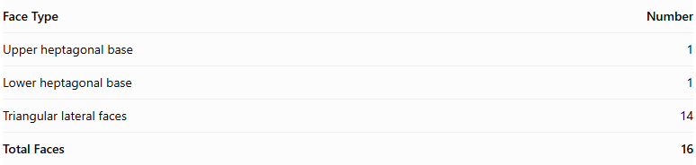
Face Type | Number
Upper heptagonal base | 1
Lower heptagonal base | 1
Triangular lateral faces | 14
Total Faces | 16

Mathematical Properties
# Source: AI Source: Provided by: [Data Path: Persons Table -> ID Column: 1, Name_En Column: Motasem Essam] -> From: [ChatGPT] on [7/25/2026]
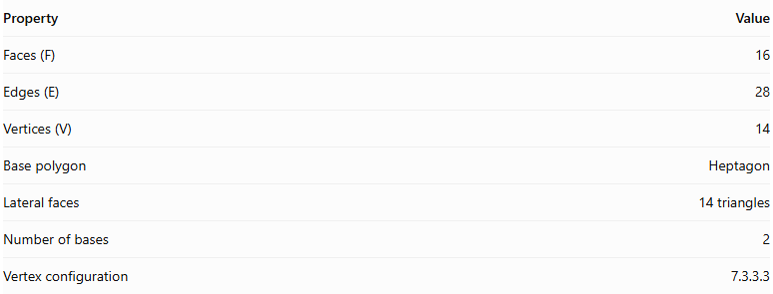
Property | Value
Faces (F) | 16
Edges (E) | 28
Vertices (V) | 14
Base polygon | Heptagon
Lateral faces | 14 triangles
Number of bases | 2
Vertex configuration | 7.3.3.3
Euler's formula:
$$V-E+F=2$$
$$14-28+16=2$$
Regular Heptagonal Antiprism
In a regular heptagonal antiprism:
- Both heptagonal bases are regular and congruent.
- The upper and lower bases are rotated relative to each other, typically by approximately ${25.714}^{∘}$.
- The fourteen lateral triangular faces are equilateral.
- The vertices have the same local arrangement.

Constructing Heptagonal Antiprism in Solid Geometry

Geometric Instruments Used
# Source: AI Source: Provided by: [Data Path: Persons Table -> ID Column: 1, Name_En Column: Motasem Essam] -> From: [ChatGPT] on [7/25/2026]
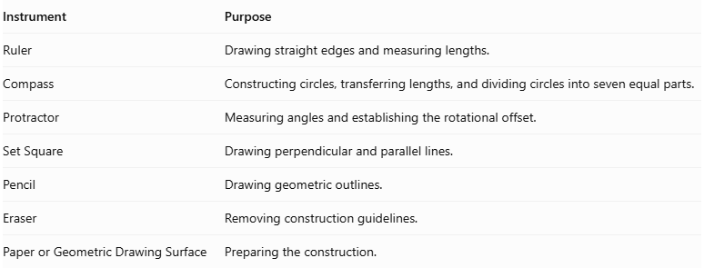
Instrument | Purpose
Ruler | Drawing straight edges and measuring lengths.
Compass | Constructing circles, transferring lengths, and dividing circles into seven equal parts.
Protractor | Measuring angles and establishing the rotational offset.
Set Square | Drawing perpendicular and parallel lines.
Pencil | Drawing geometric outlines.
Eraser | Removing construction guidelines.
Paper or Geometric Drawing Surface | Preparing the construction.

Instrument-Based Construction Procedures
# Source: AI Source: Provided by: [Data Path: Persons Table -> ID Column: 1, Name_En Column: Motasem Essam] -> From: [ChatGPT] on [7/25/2026]
The heptagonal antiprism can be constructed using geometric instruments and classical geometric drawing techniques, without using coordinate-based construction.

Constructing the Lower Heptagonal Base
# Source: AI Source: Provided by: [Data Path: Persons Table -> ID Column: 1, Name_En Column: Motasem Essam] -> From: [ChatGPT] on [7/25/2026]
- Draw a circle using a compass.
- Divide the circle into seven equal angular sections.
- Each central angle measures:
$$\frac{{360}^{∘}}{7}≈{51.4286}^{∘}$$
- Mark the seven vertices on the circumference.
- Connect consecutive vertices using a ruler to form a regular heptagon.
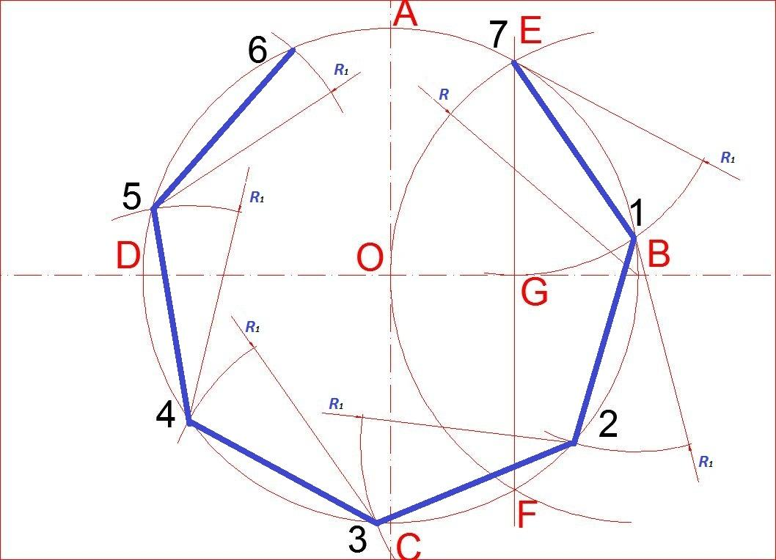

Constructing the Upper Heptagonal Base
# Source: AI Source: Provided by: [Data Path: Persons Table -> ID Column: 1, Name_En Column: Motasem Essam] -> From: [ChatGPT] on [7/25/2026]
- Draw a second regular heptagon congruent to the lower base.
- Position it above and parallel to the lower heptagon.
- Rotate its orientation by half the central angle:
$$\frac{{360}^{∘}}{14}=\frac{{180}^{∘}}{7}$$
$$\boxed{α≈{25.7143}^{∘}}$$
- Maintain the same side length and geometric proportions.

Connecting the Two Bases
# Source: AI Source: Provided by: [Data Path: Persons Table -> ID Column: 1, Name_En Column: Motasem Essam] -> From: [ChatGPT] on [7/25/2026]
- Connect each vertex of the lower heptagon to the two nearest vertices of the upper heptagon.
- Repeat the connections around the entire solid.
- Ensure the connecting edges alternate between the upper and lower bases.
- Form fourteen triangular lateral faces.
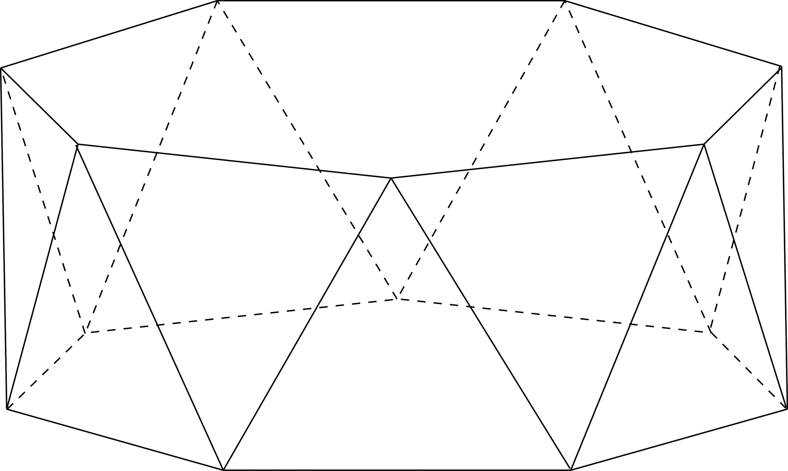

Completing the Solid
# Source: AI Source: Provided by: [Data Path: Persons Table -> ID Column: 1, Name_En Column: Motasem Essam] -> From: [ChatGPT] on [7/25/2026]
- Complete all fourteen triangular lateral faces.
- Emphasize the visible edges.
- Use dashed lines for hidden edges when necessary.
- Verify that both heptagonal bases are congruent and parallel.
- Check that the upper base has the correct rotational offset of approximately ${25.7143}^{∘}$.
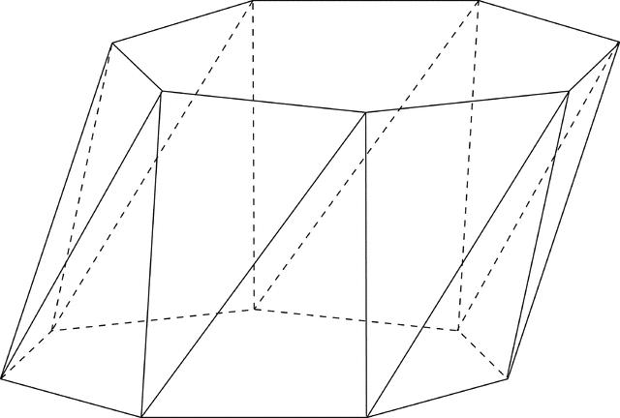

Constructing a Net
# Source: AI Source: Provided by: [Data Path: Persons Table -> ID Column: 1, Name_En Column: Motasem Essam] -> From: [ChatGPT] on [7/25/2026]
A net of a heptagonal antiprism contains:
- Two congruent heptagonal bases.
- Fourteen triangular lateral faces.
- A connected arrangement of faces with matching edge lengths and correct face adjacency.
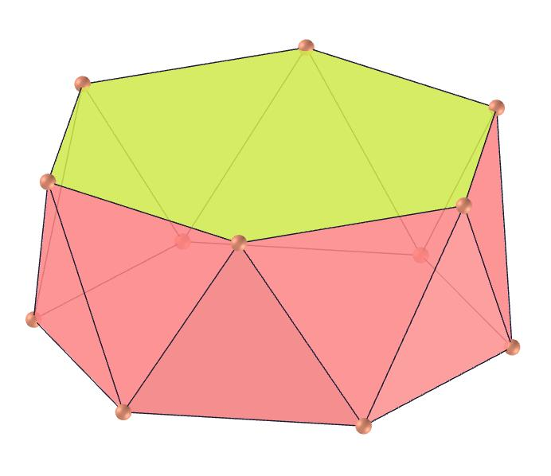

Key Points
# Source: AI Source: Provided by: [Data Path: Persons Table -> ID Column: 1, Name_En Column: Motasem Essam] -> From: [ChatGPT] on [7/25/2026]
- It has two parallel heptagonal bases.
- The bases are rotated relative to each other.
- It has fourteen triangular lateral faces.
- It contains 16 faces, 28 edges, and 14 vertices.
- Its regular form is a uniform polyhedron.

Classification
# Source: AI Source: Provided by: [Data Path: Persons Table -> ID Column: 1, Name_En Column: Motasem Essam] -> From: [ChatGPT] on [7/25/2026]
Solid Geometry
└── Types of Solids
└── Antiprism
└── Types of Antiprisms
└── Heptagonal Antiprism
├── Upper Heptagonal Base
├── Lower Heptagonal Base
└── Triangular Lateral Faces

Conclusion
# Source: AI Source: Provided by: [Data Path: Persons Table -> ID Column: 1, Name_En Column: Motasem Essam] -> From: [ChatGPT] on [7/25/2026]
A Heptagonal Antiprism is an antiprism with two congruent heptagonal bases and fourteen triangular lateral faces, arranged in a twisted configuration.

